**RTLB CLUSTER 16 - NAWTON SCHOOL**

**Update to Schools – Term Three 2023**

**Contacts for Graeme Nobilo, Cluster Manager**

Please feel free to contact me in any of the following ways:

* Mobile: 027 623 9425
* Work: (07) 8477420
* Email: gnobilo@rtlbcluster16.co.nz

Kia ora Cluster Principals and SENCOs / LSCs

I hope term three has begun positively for you. It’s hard to believe we are already half way through the school year. I hope you all have managed to enjoy some quality non-contact time.

Thank you for the support that you continue to show RTLB Cluster 16. We look forward to continuing to support students, whānau and schools. I enjoy challenges that provide the cluster with opportunities for improvement so please do not hesitate to contact me if you would like the cluster to review any aspect of our work.

**Staffing**

We welcome Layla Rawnsley to our cluster. Layla previously spent a short amount of time as an RTLB in Cluster 17. We were fortunate to be able to negotiate an early start for Layla as her original start date was day one, term three. She is hosted in the Vardon School office. We look forward to Layla positively contributing to our ever expanding cluster kete of knowledge and expertise.

**Requests for Support (RFS)**

It is vitally important that we have the correct information on the requests from your school e.g. teacher’s name, email address, teacher’s signed consent, parent’s signed consent, room number. Is there an RTLB currently working in the room? RFS for students in Year 1-6 please include oral language data.

**RTLB Database**

Reminder - if you need assistance regarding eRTLB, please contact your Liaison RTLB.

**Review and Intake Meetings**

R&I meetings are held at 8:30am every Thursday. If you wish to have a student considered for the RTLB service, please ensure you have completed the online Request for Support (RFS) following a discussion with your Liaison RTLB.

**In Class Support (ICS)**

We have been informed that MOE will again be funding 180 students from within our cluster with In-Class Support (ICS) funding for 2024. RTLB Cluster 16 is assisting MoE Learning Support in facilitating the identification process of those students who most need the support. Electronic application packs should have been emailed to the school email address that we have recorded for your school, and to your liaison RTLB. If you have not received your electronic pack by the end of week one, term three please contact

[kpetchell@rtlbcluster16.co.nz](mailto:kpetchell@rtlbcluster16.co.nz) Please note that all students receiving ICS funding for 2023 will need to be reapplied for if they are still at curriculum level 1 for numeracy and literacy.

If you have any questions or require information pertaining to ICS, please contact your liaison RTLB or Practice Leader Kay Petchell - [kpetchell@rtlbcluster16.co.nz](mailto:kpetchell@rtlbcluster16.co.nz)

**Learning Support Funding**

Reminder - RTLB can apply for Learning Support Funding at a maximum of $400.00 per term for two terms. Note: This application is an outcome from the collaborative action plan. Learning Support Funding applications are received and considered weekly.

**Incredible Years for Teachers (IYT)**

If you would like to add a teacher/s to the waitlist for an IYT course next year please contact RTLB Joanna Crawshay - [jcrawshay@rtlbcluster16.co.nz](mailto:jcrawshay@rtlbcluster16.co.nz)

**Incredible Years Teacher - Autism (IYT-A)**

Junior school teachers are invited to register for future IYT-A courses in Hamilton. Criteria for registering: Must have a student with autism (does not have to have a diagnosis) **or** a severe language delay in their class. This programme is run over 6 sessions (9-12.30pm) with visits after session 2 and 4. MoE pays $900.00 for the cost of a reliever. Teachers registering should register here: <https://app.forms.education.govt.nz/forms/view/iya001>

If you would like the student's LA to attend with the teacher, please contact RTLB Joanna Crawshay to discuss. Another course will be run in Term 4 and more in 2024.

If you have any other questions or require information pertaining to IY, please contact Joanna - [jcrawshay@rtlbcluster16.co.nz](mailto:jcrawshay@rtlbcluster16.co.nz)

**Te Waka Tamariki (formerly Children’s Team):**

If you have any questions or require information pertaining to the work of Te Waka Tamariki, please contact RTLB Gayle Addy -[gaddy@rtlbcluster16.co.nz](mailto:gaddy@rtlbcluster16.co.nz)

**Gateway**

If you have any questions or require information pertaining to Gateway, please contact Practice Leader Leeana Herewini - [lherewini@rtlbcluster16.co.nz](mailto:lherewini@rtlbcluster16.co.nz)

**Special Assessment Conditions (SAC)**

If any secondary school or wharekura requires information about the SAC process, please contact RTLB Sue Taylor - [staylor@rtlbcluster16.co.nz](mailto:staylor@rtlbcluster16.co.nz)

**MoE - Attendance and Engagement Strategy**

Overview

The Attendance Service supports schools to effectively address and reduce unjustified absence rates and supports the re-enrolment and attendance of non-enrolled students. The Attendance Service primarily works with ākonga aged from 6-16 years old who are chronically absent (mostly attending less than 70% of the time) or who are not enrolled in any school.

Delivery

The AS works with ākonga and their whānau, schools and kura, iwi and hapū, community partners and agencies to address the root causes of non-attendance. Services must work within the context of the family and whānau to achieve a sustainable return to school. Each AS will tailor its approach based on local knowledge of what works in the community.

If you have any questions or require information pertaining to the Attendance and Engagement Strategy, please contact Cameron Frethey [cameron.frethey@education.govt.nz](mailto:cameron.frethey@education.govt.nz)

**RTLB Cluster 16**

The date range for the following graphs: 01/01/2023 – 30/06/2023 (end of term two).

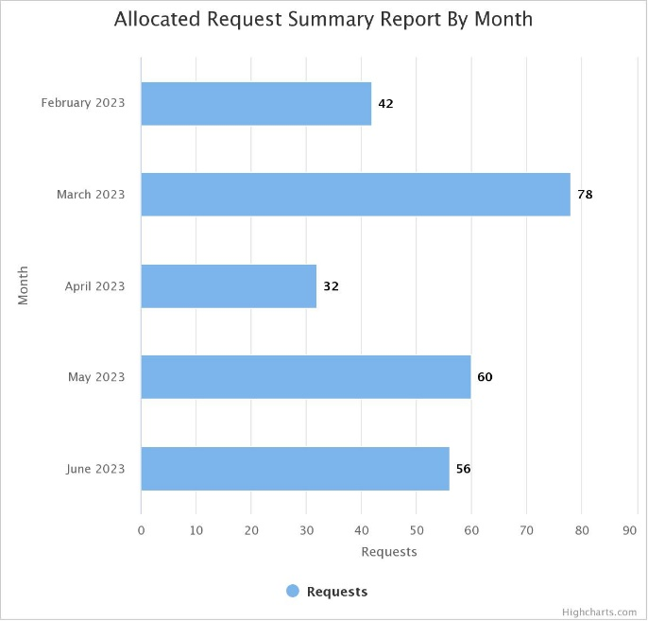 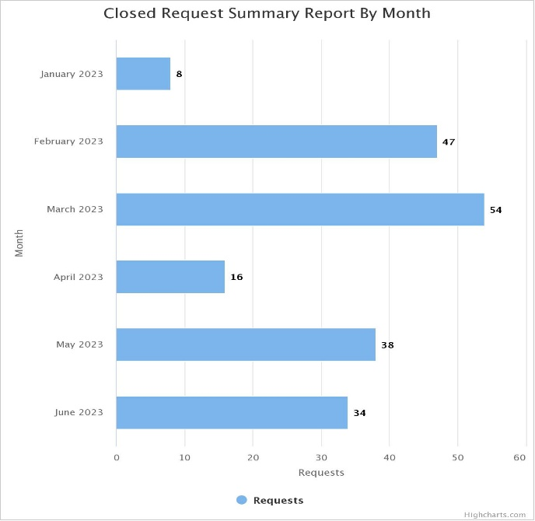

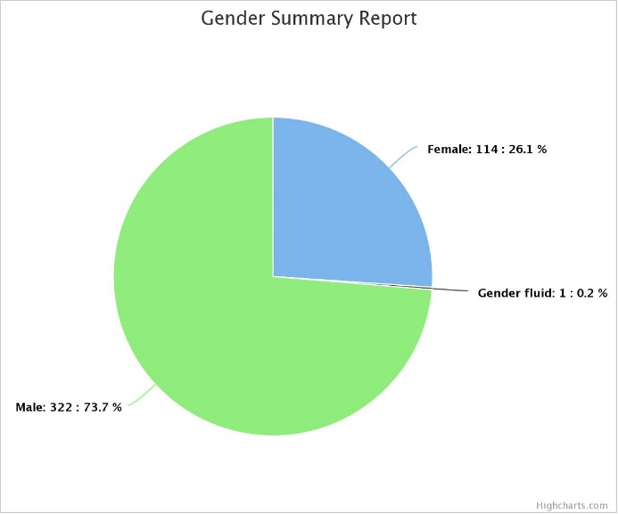 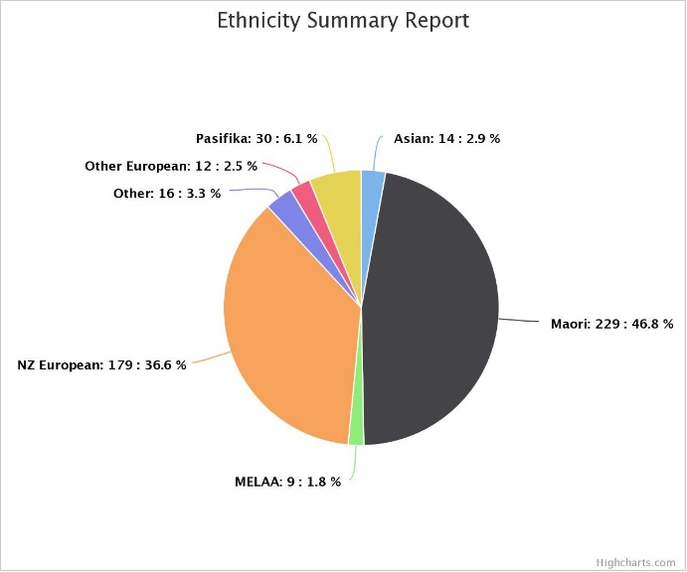

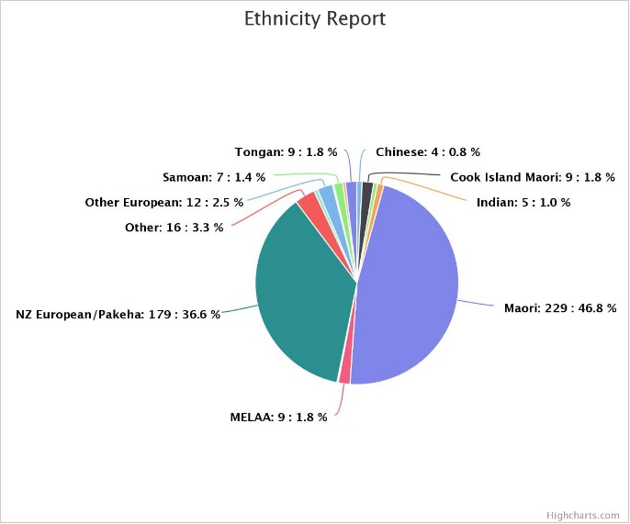 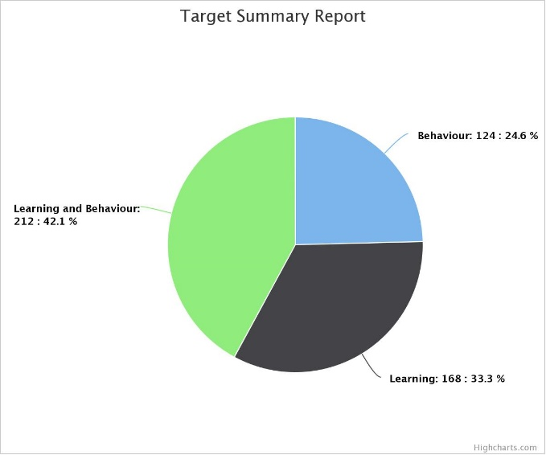

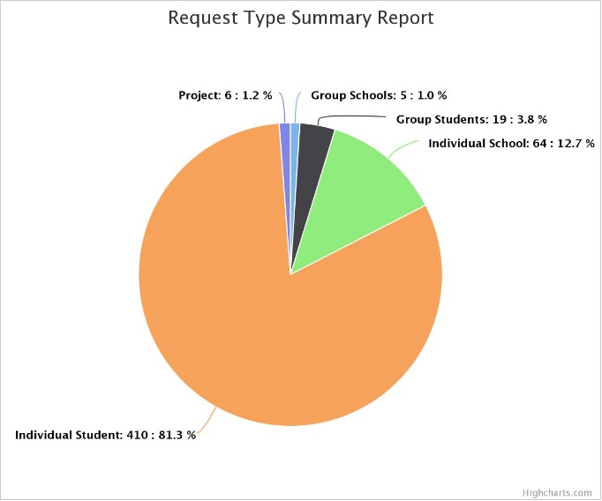 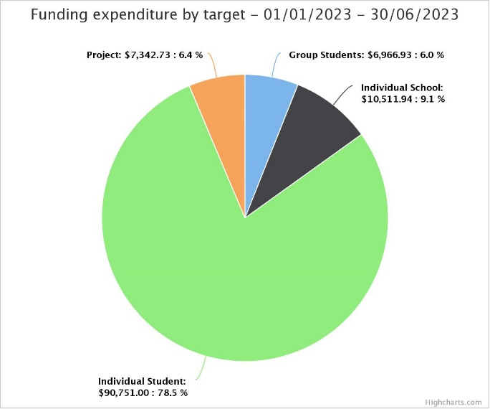

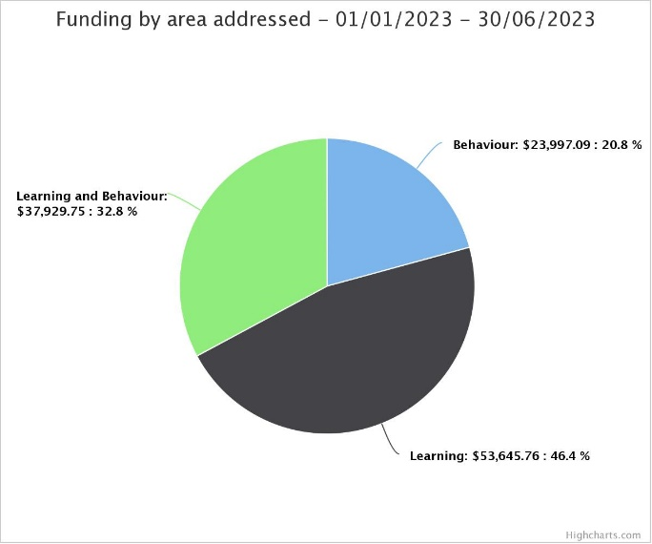

All the very best for Term Three.

Ngaa mihi

Graeme Nobilo

RTLB Cluster 16 Manager