**RTLB CLUSTER 16 - NAWTON SCHOOL**

**Update to Schools – July 2020**

**Contacts for Graeme Nobilo, Cluster Manager**

Please feel free to contact me in any of the following ways:

* Mobile: 027 6239425
* Work: (07) 8477420
* Email: gnobilo@xtra.co.nz

Kia Ora Cluster Principals and SENCOs/LSCs

I hope term three has begun positively for you. It’s hard to believe we are already half way through the school year – a year that has been like no other! I hope you all have managed to enjoy some quality non-contact time. Thank you for the support that you continue to show RTLB Cluster 16. We look forward to continuing to support students, whanau, teachers and schools. I enjoy challenges that provide the cluster with opportunities for improvement so please do not hesitate to contact me if you would like the cluster to review any aspect of our work.

**Staffing**

I would like to extend a warm welcome to two new RTLB – Jenny Bell and Leah Thompson. Their offices are at Insoll and Te Awa Rima respectively. I look forward to them contributing their knowledge and expertise to our cluster.

**Cluster Advisory Group (CAG)**

Our Cluster Advisory Group comprises:

* Lead School Principal, Rubina Wheeler, Nawton School
* Lead School BOT Rep, Bill Featherstone, Nawton School
* RTLB Cluster 16 Manager, Graeme Nobilo
* RTLB Cluster 16 Rep, Louise Handley
* Principal Rep, Marcus Freke, Endeavour School
* Principal Rep, Clive Hamill, Melville High School
* Learning Support Manager, Paul Mitchell

**eRTLB / Database**

Reminder - if you need any assistance, please contact your Liaison RTLB.

**Review and Intake Meetings**

RTLB Cluster 16 R & I meetings are held at 8:30am every Thursday. If you wish to have RTLB support, please ensure you have completed the online `Request for Support’ and notified your Liaison RTLB.

**In Class Support (ICS)**

MOE funds 180 students in our cluster with In-Class Support (ICS) funding. Nominations for ICS funding for 2021 will be called for this term. In Week 7 of Term 3 a google document/template will be shared by RTLB Kathy Meredith with SENCOs, LSCs and Liaison RTLB for all 83 schools and kura in Cluster 16. This google doc with include the criteria and information required for the student to be considered. Nominations must be shared with Kathy by the end of Week 1 Term 4.

If you have any questions or require information pertaining to ICS, please contact RTLB Kathy Meredith - kathy@silverdale.school.nz

**Children’s Teams:**

If you have any questions or require information pertaining to the work of the Children’s Team, please contact RTLB Gayle Addy -[gayle@hamwest.school.nz](mailto:gayle@hamwest.school.nz)

**Incredible Years for Teachers (IYT)**

If you have any questions or require information pertaining to IYT, please contact RTLB Bette-May Waine - bettemayw@gmail.com

**Gateway**

If you have any questions or require information pertaining to Gateway, please contact Lead RTLB Louise Handley - louise.handley@vardon.school.nz

**PB4L**

If you have any questions or require information pertaining to PB4L, please contact RTLB Tracey Lee Perry - t.perry@fraser.school.nz

**Special Assessment Conditions (SAC)**

If any secondary school or wharekura requires information about the SAC process, please contact RTLB Sue Taylor - [staylor@fairfieldintermediate.school.nz](mailto:staylor@fairfieldintermediate.school.nz)

The date range for the following graphs: 01/01/2020 – 03/06/2020 (end of term two).

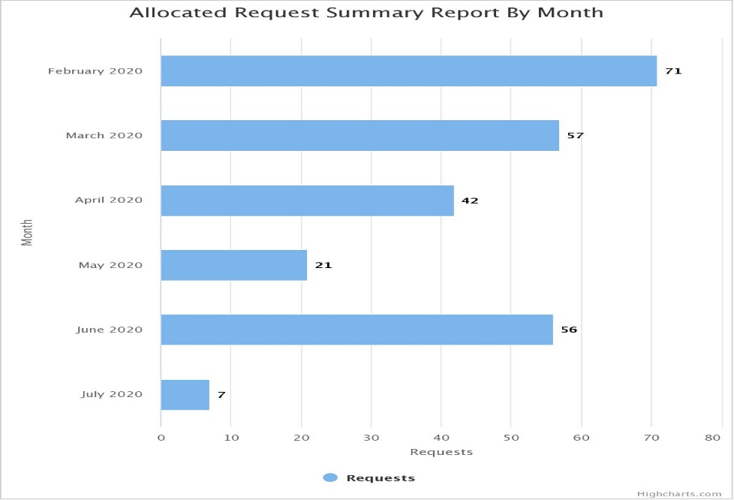

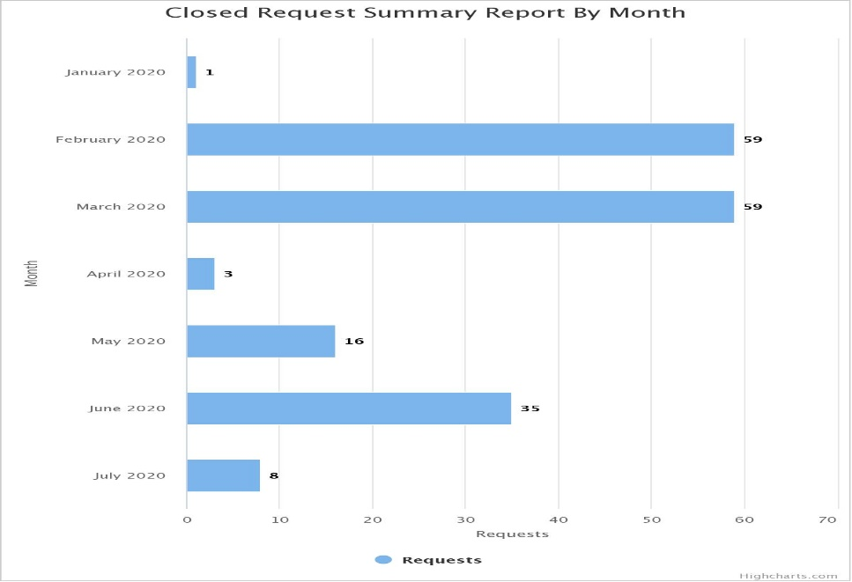

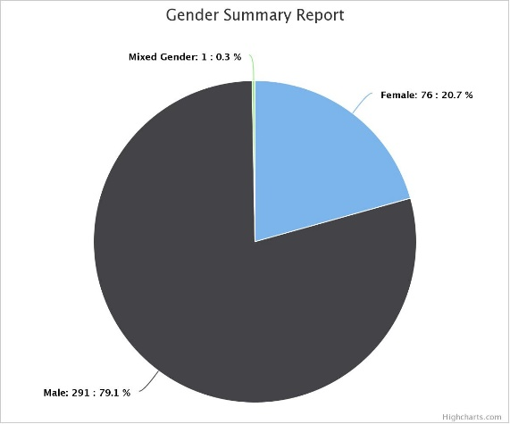

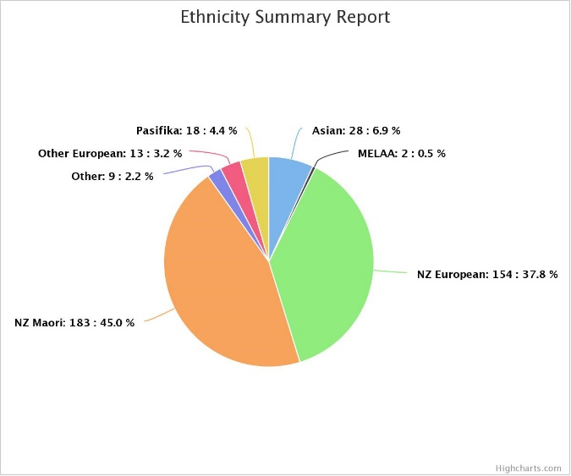 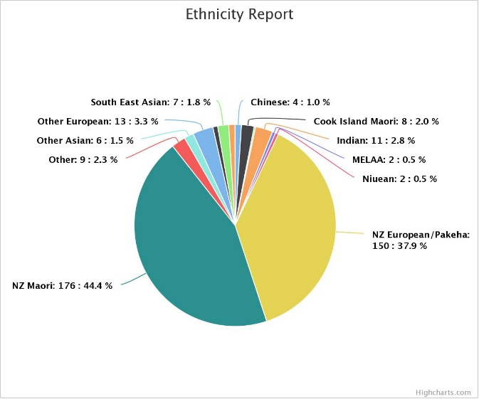

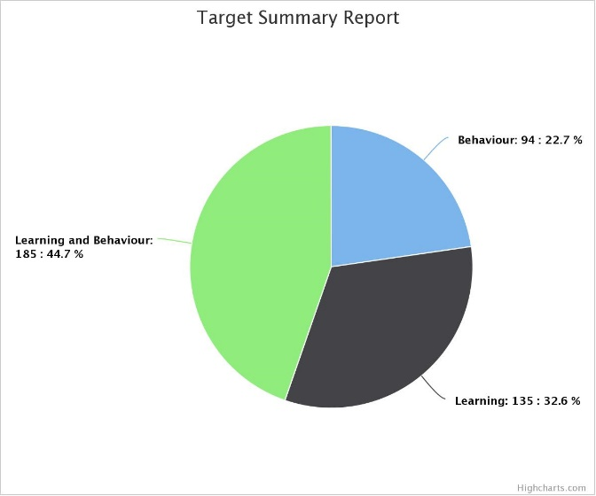 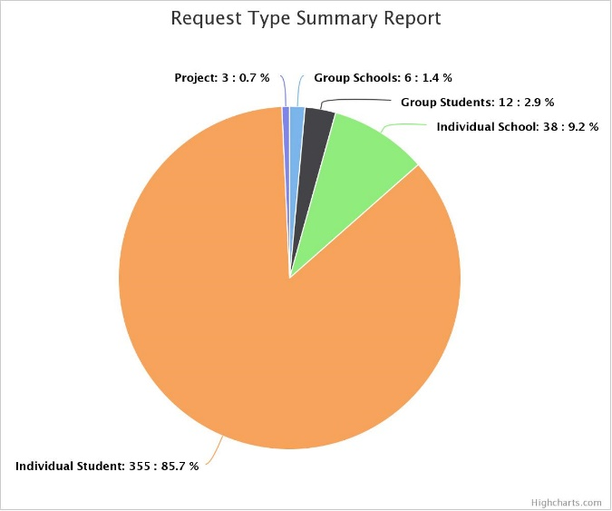

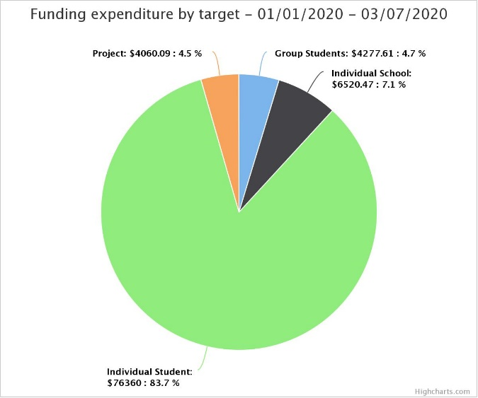 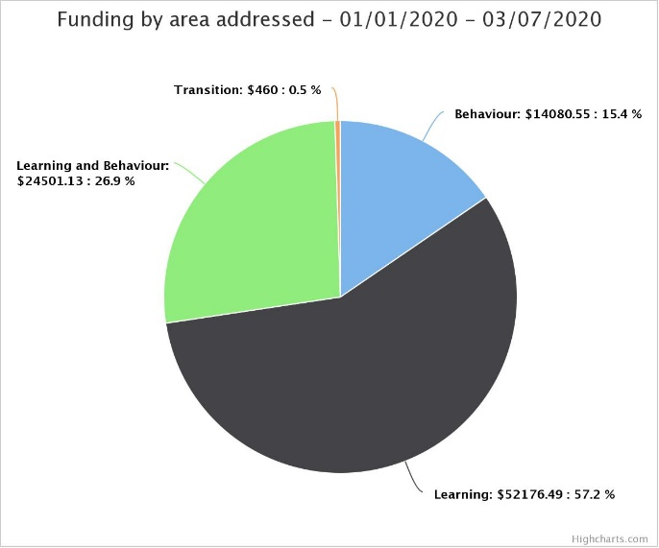

Kind regards. Graeme Nobilo, RTLB Cluster 16 Manager.